**Advance Excel Assignment 17**

1. What are modules in VBA and describe in detail the importance of creating a module?

Ans. VBA module is a “.bcf” extension file that holds the code in the [visual basic editor](https://excelchamps.com/vba/visual-basic-editor/). Each module has its own code window where you can write. You can insert a new module, delete, backup, and import it. In simple words, it’s like a text file that you open in the notepad.

**Insert a VBA Module**

1. First of all, open the Project Window if it’s not there already.
2. Next, right-click on the project in which you want to insert a module.
3. After that, go to the Insert and click on the “Module”.
4. Once you do that, you will instantly get a new module and can open its code window to write the code.

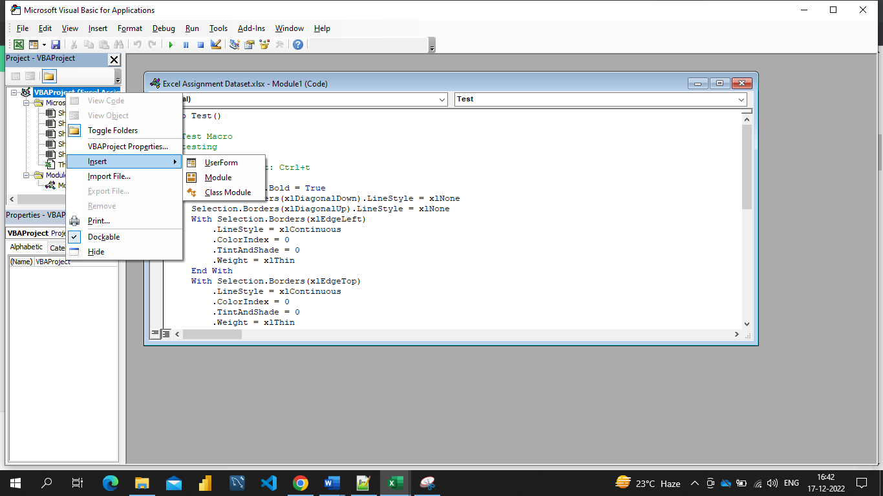

You can also go to the insert menu and then the module to insert it.

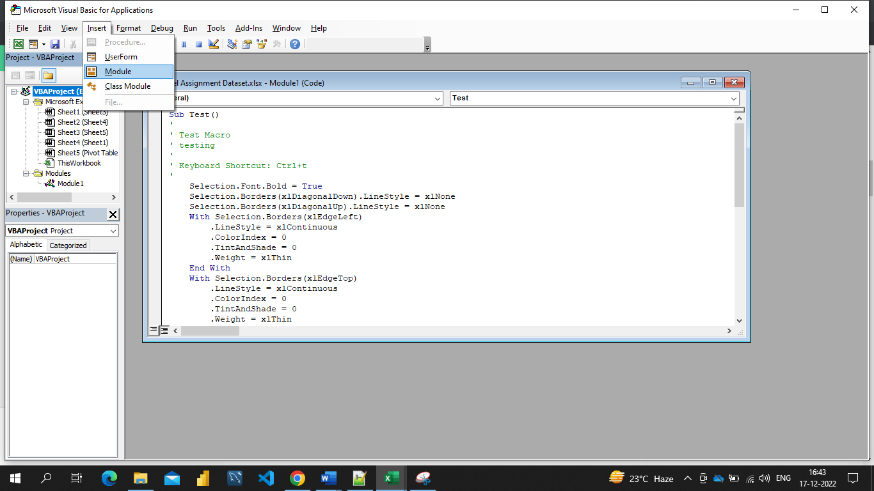

When you insert a new module, VBA creates a separate folder for all the modules that you have in the project.

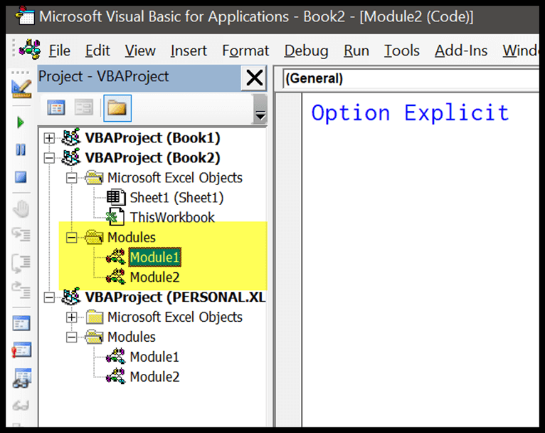

1. What is Class Module and what is the difference between a Class Module and a Module?

Ans. A class is more of a unit, and a module is essentially a loose collection of stuff like functions, variables, or even classes.

In a public module, classes in the project have access to the functions and variables of the module. You don't have to specify the module name to address one.

When you insert a new module, user can see an option to insert a class module. But there’s a slight difference between both modules. User can also define methods, properties, and events for those objects. And when user create a new object from the class module, user can refer to it from the standard module as well.

1. What are Procedures? What is a Function Procedure and a Property Procedure?

Ans. A procedure is a block of Visual Basic statements inside Sub, End Sub statements. Procedures do not return values.

Property Procedure : A property procedure is a series of Visual Basic statements that manipulate a custom property on a module, class, or structure. Property procedures are also known as property accessors.

Visual Basic provides for the following property procedures:

A Get procedure returns the value of a property. It is called when you access the property in an expression.

A Set procedure sets a property to a value, including an object reference. It is called when you assign a value to the property.

Function Procedure : A Function procedure is a series of Visual Basic statements enclosed by the Function and End Function statements. The Function procedure performs a task and then returns control to the calling code. When it returns control, it also returns a value to the calling code.

Each time the procedure is called, its statements run, starting with the first executable statement after the Function statement and ending with the first End Function, Exit Function, or Return statement encountered.

You can define a Function procedure in a module, class, or structure. It is Public by default, which means you can call it from anywhere in your application that has access to the module, class, or structure in which you defined it.

A Function procedure can take arguments, such as constants, variables, or expressions, which are passed to it by the calling code.

1. What is a sub procedure and what are all the parts of a sub procedure and when are they used?

Ans. A Sub procedure is a series of Visual Basic statements enclosed by the Sub and End Sub statements. The Sub procedure performs a task and then returns control to the calling code, but it does not return a value to the calling code.

Each time the procedure is called, its statements are executed, starting with the first executable statement after the Sub statement and ending with the first End Sub, Exit Sub, or Return statement encountered.

You can define a Sub procedure in modules, classes, and structures. By default, it is Public, which means you can call it from anywhere in your application that has access to the module, class, or structure in which you defined it. The term method describes a Sub or Function procedure that is accessed from outside its defining module, class, or structure.

Following is the syntax of the Sub procedure:

[Access_Specifier ] Sub Sub_name [ (parameterList) ]

[ Block of Statement to be executed ]

End Sub

Where,

* Access_Specifier: It defines the access level of the procedure such as public, private or friend, Protected, etc. and information about the overloading, overriding, shadowing to access the method.
* Sub_name: The Sub_name indicates the name of the Sub that should be unique.
* ParameterList: It defines the list of the parameters to send or retrieve data from a method.

1. How do you add comments in a VBA code? How do you add multiple lines of comments in a VBA code?

Ans. A VBA COMMENT is a green line of text that helps you to describe the written code. In simple words, a comment is a line of text which is not a code and VBA ignores it while executing the code. It’s a good practice (I’d say one of the best) to add comments in your VBA codes.

Advantages of using a Comment

* Helps you to Document your Work: You can use a comment to describe how code works, which can help you in the future to recall it easily or any other user.
* Track the Changes: If some codes need you to change them frequently you can use comments to track or record changes within the code.
* Describe a Function Procedure: When you write a procedure you can add a comment at the starting to describe the purpose of this procedure and how it works.
* Describe a Variable: Variables are one of the most important things that you need to use while writing a VBA code and you can use a comment to describe a variable.
* Debug Your Code: You can use VBA comments to debug the code by converting code lines into comments for testing.

Add a Comment in a VBA Code

Steps you need to follow to add a comment in a VBA code:

1. First, click on the line where you want to insert the comment.
2. After that, type an APOSTROPHE using your keyboard key.
3. Next, type the comment that you want to add to the code.
4. In the end, hit enter to move to the new line and the comment will turn green.

Enter a Multi-Line VBA Comment

The easiest way is to select all the lines and then use the comment button from the toolbar or you can also add an APOSTROPHE at the starting of each line.

